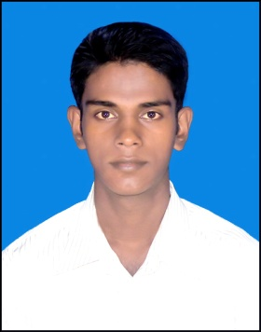**CURRICULUM-VITA**

**OF**

* **Contact Address:**

**Subroto Das**

Diploma in Environmental Engineering

Mobile: +8801966016091

+8801772649882

* **Career Objective:**

To prove myself as a quick learner and highly energetic person to face any challenge in such an organization in field of Electronics Engineering where the contribution will be acknowledged, If I would be given an opportunity.

* Education Qualification :

### Diploma In Engineering:

* Degree : Diploma in Environmental Engineering.
* Institute : Khulna Polytechnic Institute
* Board : Bangladesh Technical Education Board
* Duration of Course : Four Years.
* Passing Year : 2016
* CGPA : 3.07 (out of 4.00)

### Secondary School Certificate:

* School Name : Shahpur High School
* Group : Science
* Board : Jessore
* Passing Year : 2012
* GPA : 4.25 (out of 5.00)
* Industrial Attachment:
* Organization Name : Education Complex, Khulna
* Address : Khulna.
* Training Title : Building Construction
* Duration : Three Months.
* Language Proficiency:
* English : Reading, writing and speaking ability.
* Bengali : Mother tongue.
* Skills :
* Communication with Business Related Peoples.
* Punctual, Professional, Self-Motivated, Communicative & Friendly.
* Working Capability in-group & Individual Working Condition.
* Accept Responsibility & do it honestly.
* Computer Skill:
* Microsoft Office, Microsoft Word, Microsoft Excel, Microsoft Power Point.
* Internet Browsing.
* Personal Details:
* Name : Subroto Das
* Father’s Name : Shannashi Das
* Mother’s Name : Parul Das
* Date of Birth : 08/12/1995
* Nationality : Bangladeshi (By Birth)
* Sex : Male
* Marital Status : Single
* Height : 5 ft 4 inch
* Weight : 50 kg.
* Religion : Hindu.
* Present Address:
* Village : Madhugram
* P.O : Shahpur
* P.S : Dumuria
* District : Khulna
* Permanent Address:
* Village : Madhugram
* P.O : Shahpur
* P.S : Dumuria
* District : Khulna
* Reference:
* Name : Mollah Mujibor Rahman
* Designation : Chiep Instructor (Environmental Technology)
* Origination : Khulna Polytechnic Institute,Khulna
* Mobile No : +8801712-584808
* Interests:

Reading Newspaper, Sports Like Cricket, Football etc. Swimming, Traveling, Gardening and in Challenging works.

* Certification:

I, honestly declare that above information is true and correct to the best my knowledge. If any information given is found false or incorrect, I am liable for this.



|  |  |
| --- | --- |
| Date: | .............................  Signature |